|  |
| --- |
| Heriot-Watt University |
| Design Report |
| Advanced Interaction Design F21AD |
|  |
| **Group 4: Sam Haley (H00103552), Mary Holderby (H00180635), Gordon Rennie (H00155853)** |
| **2/26/2019** |

**Note:** This document uses APA Referencing Format. (Details found at <https://www.ukessays.com/referencing/apa/>.)

Table of Contents

1 Background 5

2 Stakeholder and Task Analysis 6

3 Requirements Analysis 6

4 Storyboard Design 7

5 Prototype Development 8

5.1 Introduction 8

5.2 Log-in Screen 8

5.3 Home Screen 9

5.4 Medication Screen 9

5.4.1 Change Day Screen 10

5.4.2 Add Medication Screen 11

5.4.3 Medication Details Screen 11

5.5 Energy Screen 12

5.5.1 Breakdown of Energy Usage Screen 12

5.5.2 Smart Appliances Screen 13

5.6 Exercise Screen 13

5.6.1 Add Exercises Screen 14

5.6.2 Exercise Run-Through 14

5.7 Smart Robot (Cozmo) 15

5.8 Settings Screen 16

5.9 Prototype Design Summary 16

6 Appendix 17

6.1 Gantt Chart 17

6.2 Personae 18

6.2.1 Al 18

6.2.2 Kitty 19

6.2.3 Joe 20

6.3 Scenarios and Use-Case 21

6.3.1 Scenario 1 – Log-in Screen, User 21

6.3.2 Scenario 2 – User encounters problem 21

6.3.3 Scenario 3 – Home Screen, Medication Bottle Button Flashing, Chime Sounding 21

6.3.4 Scenario 4 – Home Screen, No Chime Sounding, No Button flashing 22

6.3.5 Scenario 5 – Home Screen, No Chime Sounding, No Button flashing 22

6.3.6 Scenario 6 – Home Screen, No Chime Sounding, No Button flashing 22

6.3.7 Scenario 7 – Home Screen, No Chime Sounding, No Button flashing 22

6.3.8 Scenario 8 – Home Screen, No Chime Sounding, No Button flashing 23

6.3.9 Scenario 9 – Home Screen, No Chime Sounding, No Button flashing 23

6.3.10 Scenario 10 – Home Screen, No Chime Sounding, No Button flashing 23

6.3.11 Scenario 11 – Home Screen, No Chime Sounding, No Button flashing 23

6.3.12 Use-Case for Cozmo Robot 24

6.4 Proposed Design for 1st February Presentation 25

6.5 Code for Cozmo Robot 27

7 Prototype Screenshots 27

7.1.1 Log-In Screen 27

7.1.2 Home Screen 28

7.1.3 Medication Screen 29

7.1.4 Medication screen change day 30

7.1.5 Add Medication Screen 30

7.1.6 Medication Details Screen 31

7.1.7 Energy Screen 31

7.1.8 Energy Usage Breakdown Screen 32

7.1.9 Smart Appliances Screen 32

7.1.10 Exercise Screen 33

7.1.11 Add Exercises Screen 33

7.1.12 Exercise Run-Through 34

7.1.13 Smart Robot (Cozmo) 34

7.1.14 Settings Screen 35

8 Logbook 35

9 References 40

# Background

This is a design report for our proposal to build an interactive device for people generally of age 65+ with limited mobility. The specified requirements that this device should provide are – the support of exercise, reminders to take medicine at correct times, communication of energy use and tips to decrease this, and a mechanism to request a small robot fetch small items of use within the home.

Forlizzi and Battarbee (2004) described three types of interactions that could be produced between a user and a product: (1) an interaction which focuses on the product and requires some thinking or cognitive action from the user; (2) an interaction which fits into a user’s routine without interrupting it, termed ‘fluent’; and (3) an interaction which develops a relationship between the user and the product. Our concept for this design attempts to provide an effortless interaction so that the user can proceed with the daily tasks described above, while also providing a useful link to a helpful robot.

This has led the design to provide ‘button’ icons which depict the function which pressing that ‘button’ will provide. The intention is to make the screen facilities describe themselves to the user so there is no requirement to puzzle out what can be done through interaction or to find the manual to know how to use the screens. A similar approach was taken to the robotic interaction with the application and the robot working in harmony to guide a user through the interaction. Application buttons are a larger size than most applications in circulation, partly to enhance their usability but also to ensure a screen layout with only a few images on it to reduce busyness and distraction; see Figure 1 below.

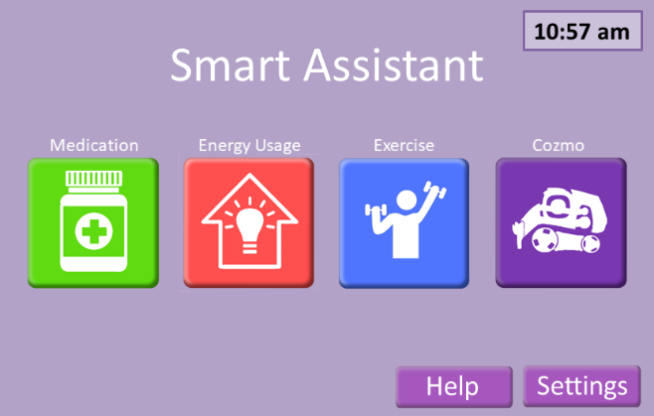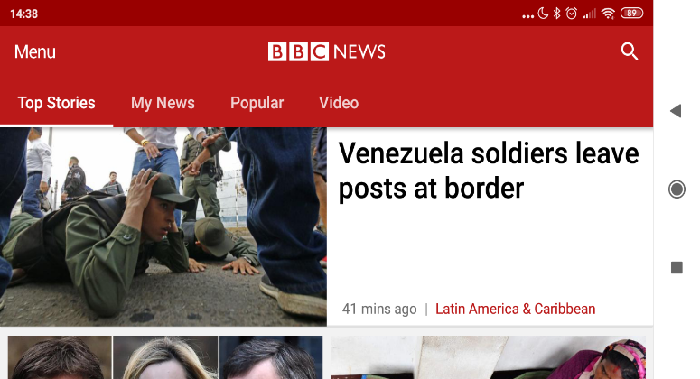

Figure 1 - A screen comparison to show the relative size of buttons and icons. The application design ensures that buttons are easy to press and difficult to miss. This is in contrast to the BBC news application which has smaller buttons which are also difficult to see due to them being the same as the background (see the title bar) Both screens are shown with the same height and width (BBC, 2019). This is an indicator of how large the icons and buttons for the proposed Interactive design. It clearly demonstrates the simplicity and ease of interaction with the main screen opposed to the usability problems as presented by the BBC application.

# Stakeholder and Task Analysis

The stakeholders who will be inputting and updating information for this device and who will be interacting through this device include:

* Individual in home: primary user
* Medical staff: doctor, nurse, therapists
* Emergency services: ambulance, fire personnel
* Developers: robot, interaction system

The location in which this device will be used:

* Primary use within home which has smart device monitoring of energy use
* Secondary use within medical offices of doctor, nurse, and variety of therapist locations

The medication functionality has been designed with the hope that a medical member of staff will work in conjunction with the user to update the details of a users’ medication. In the same manner the exercise area could be updated in conjunction with a physiotherapist who may recommend new activities.

The details of the personae for whom the interaction device has been designed appear in the Appendix as 6.2 Personae.

# Requirements Analysis

The requirements listed in the Coursework specification are a mechanism to undertake exercise, reminders to take medication on time, information on home energy use with tips to minimise when desired, and a home robot to fetch items. The requirements were extended during the design to support interaction with medical staff as the group believed this would be a useful addition. The system of interactive screens was expanded with additional ‘supporting’ screens to give the user a unified and complete set of interactive opportunities to benefit their lives despite mobility and health issues. Thus, the system is structured as:

* Log-in Screen
* ‘Home’ Screen
  + Overlay Help Message
* Medication Screen
  + Overlay Warning Message
* Medication Screen Change Day
* Add Medication
* Medication - Details
* Home Energy
* Energy Breakdown Screen
* Smart Appliances Screen
* Exercise Screen
* Add Exercises Screen
* Smart Robot Cozmo
* Settings Screen

Simplicity and consistency were key concepts during the design process. For this reason, the screens were designed to convey as much information about the function of the application with as little text as possible. As mentioned above large buttons with a 3D effect have been used throughout the application to make it clear what can be pressed. Isakovic *et al.* (2016) utilized a questionnaire to consider some design criteria which included use of buttons which relied on simple images to convey their purpose. Our design utilizes these criteria to communicate the functional area on the face of each button. Furthermore, Iskovic *et al*. (2016) chose colours which were muted and restricted the functionality of each screen in their design of an interactive device for older diabetics. Our application allows users to personalise the colour scheme.

The UK Government has provided additional design advice for all services with disabled users (Pun, 2016). Their advice suggested that screen elements have a large space around them while not crowding interactions; they should utilise consistent layouts. For our design, consistency is achieved through use of the same basic layout for our screens, with the time shown in the top right corner, a back button if applicable in the lower left corner, settings / edit in the lower right corner and the main features in the middle of the screen.

# Storyboard Design

The design as proposed for the presentation on 1st February 2019 is shown in the Appendix 6.4. Several alterations were made on the basis of the feedback received from the presentation and also on subsequent lecture material.

Alterations due to feedback:

* The design did not notify the user when a designated time to take a medicine had been missed. The medication button on the home page now flashes if it is time to take a prescribed medication.
* The design for exercises did not provide motivation for the user to engage in exercise (as per the original specification). Additional research was conducted to pinpoint ways in which our personae – elderly people with limited mobility – might be motivated. One observation found in several websites is that people will tend to do an activity or exercise if it is something they enjoy (Baylor Scott & White Health, 2012; Myers, 2015). Two sports highlighted by Myers (2015) as enjoyed by older people are golf and bowling. These sports, bowling and golf, were added. All exercises make use of tracking sensors through which the application gives feedback for good-form, as a way of congratulating users when they undertake the exercises.
* The design of the energy screen did not encourage engagement. The screens did not contain an indication of daily usage which might be a motivation to interact with the energy displays. Amendments were made to the energy use screens. A tip bar was added with a suggestion of how energy consumption might be lowered. A further interaction was added so that the user can select the bar of a given day and be shown what devices are consuming what energy, with a further comparison to usage on that day for each of three weeks previous. The second screen was amended to remove the floor-plan and offer a simple method for adding/deleting a smart appliance.
* Following a course lecture regarding security, the group agreed the design needed a log-in screen. To make this log-in as effortless as possible for the user, the application utilises a facial-recognition camera so that the user would not have to remember a password.

# Prototype Development

## Introduction

The prototype for our proposed design has been built to reflect feedback, course material, and research undertaken. The full set of display screens is included in the Appendix (see 7 Prototypes Screenshots), but an outline of each is given here along with supporting research. The details of scenarios for the screen interaction and of the use-case for the robot interaction appear in the Appendix as 6.3 Scenarios and Use-Case.

## Log-in Screen

**Purpose of Screen**: Offers a secure mechanism for both the user and other stakeholders to interact with the system. Prohibits fraudulent use of system.

**Background software**: Camera with facial recognition embedded into screen. This allows a seamless log-in for the user without the need for ‘password’ details. Having passed that check once a day, the primary user is ‘remembered’ so that they do not have to repeatedly log-in.

**Log-In ‘Password’ entry box**: Password allows a user to bypass the facial recognition.

**Supporting Research:** In a web article MedConfidential (2018) considered that a patient’s trust that their medical information is secure from outside knowledge is vital for full disclosure of their symptoms. Kontomanolis *et* al. (2017) highlighted how public knowledge of some medical conditions can have devastating consequences on the social position of patients. With the possibility of a malicious intruder in the home accessing a host of unsecured application mechanisms, a secure system that only permits access to authorised people gives peace of mind to the user. The user can choose to share their password – for instance to emergency services staff or their doctor - but it remains their choice alone.

## Home Screen

**Purpose of Screen**: Allow selection of the four functional areas outlined by the requirements. One further selection option permits changing display colours via a Settings screen.

**User interaction:** Five buttons which have a unique colour:

* Green, medication button will take the user to the medication page of the application (see 5.4 Medication). This button will also pulse along with a chiming sound when it is time to take a given medication.
* Red, energy/smart home button will take the user to energy page of the application (see 5.5 Energy Screen).
* Blue, exercise button. (see 5.6 Exercise Screen).
* Purple “robot” button (see 5.7 Smart Robot (Cozmo) ).
* Settings button (see 5.8 Settings).
* Help button on Home Screen that will give contact information for support.

## Medication Screen

**Purpose of Screen**: That day’s medicine dosage is displayed with an option to select ‘Taken’. It defaults to the current day.

**Inter-screen Interaction:** If a medication dosage is due, this condition will trigger a flashing image of the medication button on the Home screen and a chiming sound is played.

**User Interaction:**

* Users can select ‘Taken’ for medication. Users can navigate to the edit area. Users can access detailed information on a medication by pressing its picture.
* The day shown can be changed by pressing the “Change day” button. This actions takes the user to 5.4.1 Change Day Screen, which allow them to choose which day is of interest from a calendar.
* A ‘Edit’ button on the lower right of the screen takes the user to 5.4.2 Add Medication Screen. .

**Screen Warning**: If the user presses ‘taken’ for a medication out with the proper time, a warning screen will overlay this screen with the message that the medication should not yet be taken and what to do if the medication has already been taken. The facility to select taken on this screen is to avoid taking medication twice in the case of forgetful users and silences the warning on the home page. (See Appendix 7.1.3.1 , Medication Screen with Warning about Dosage Time).

**Supporting Research:** In “8 Creative Ways to Remember” (2014), advice is given on effective reminders. One suggestion given was to use pictures. The application shows the number of pills and at what time to take them. This method of communication is in line with the above advice and ensures vital information is given quickly and clearly.

### Change Day Screen

**Purpose of Screen:** The day to be shown can be selected, from a calendar, if the user wishes to see what medication they need to take on any given day. This screen makes it simple for a user to switch quickly between days, both past and future, to allow them to see their medication schedule.

**User Interaction:** There is one interaction devices on this screen:

* The user can select a day they wish to view their medication timetable using the calendar buttons.

### Add Medication Screen

**Purpose of Screen:** Drugs can be searched for and selected to add to or delete from the user’s medication. This screen could be used in conjunction with a doctor.

**User Interaction:** There are two interaction devices on this screen:

* There is a search box through which a list of medicines can be requested.
* From a list of possible medications returned, the desired medication can beselected.

This screen was added as a support screen. The team decided there would almost certainly be a need for medication amendments. The team designed the screen intending that medical staff and the user would work in collaboration to update the application. However, a user can access this area alone. This was included to ensure patient rights were not infringed.

**Supporting Research:** Based on the 10 rights of medication administration (Edwards & Axe, 2015) a patient must have the right to refuse medication. The design team interpreted this to include the ability to alter the medication prescribed and the reminders presented on a users’ application.

### Medication Details Screen

**Purpose of Screen:** This screen displays a medication giving its full name and information about the medication, including any side effects which should be noted.

**User Interaction:** The user may select the ‘Taken’ button. This will replicate pressing taken on screen 5.4.

The screen was developed as a support screen so that the user could clarify to themselves what a medication was and what possible side effects it might have before choosing to take it.

**Supporting Research:** Research showed that medication compliance increases as health literacy increases (Vlasnik, Aliotta & DeLor, 2005). Health literacy refers to a patients’ knowledge of medication instructions and information about what the medication is and why to take it. By increasing health literacy, it is hoped compliance will also be increased.

## Energy Screen

**Purpose of Screen:** This screen displays the energy usage by the user over the past week. It also indicates how much energy had been used by the same time each day of the week. This is done using a bar graph, one bar for each day, a ‘legend’ is used to clarify the meaning of the bars.

To aid users, tips are displayed below the bar graph making suggestions on lowering energy use. This tip bar will also be used during a users’ first interaction with the application to guide them through the energy screen as this is a complex screen offering many interactions. In this way the tip performs the function of a help box.

**User Interaction:**

* The user may tap the bar of a given day to be taken to 5.5.1 Breakdown of Energy Usage Screen.
* There is an ‘Edit’ button at the lower right. This takes the user to 7.1.9 Smart Appliances Screen.

The design is intended to motivate the user to consider their current energy usage by showing a comparison with previous usage. This was intended to put the user in competition with themselves. As well, the user can elect to control the devices monitored as ‘smart’ appliances.

**Supporting Research:** Competitions have been shown to increase engagement and likelihood of reaching self-imposed targets (Bonino, D., Corno, F. & De Russis, L. 2012).

### Energy Usage Breakdown Screen

**Purpose of Screen:** This screen displays how energy is presently being used.

**User Interaction:** Apart from the standard ‘Back’ button which displays at the lower left of all of the screens, there is no further user interaction for this screen.

The screen presents a pie chart showing what has used what percentage of the day’s energy usage. This allows users to target areas where they use more energy enabling them to make greater energy savings. This also allows users to see why they are being given certain tips. Tips to turn off lights would be linked with users’ who leave lights on in rooms they are not using.

**Supporting Research:** Two separate reports into energy conservation suggested that ‘smart’ monitoring such as is currently provided by several energy companies offers the most effective and most long-lasting motivation to cut energy usage (Darby, 2006; Allen and Janda, 2006). While the design team considered displaying usage at a specific time compared with usage over some period, the decision was taken to show what devices were using the energy along with a tip that could tie the usage to an opportunity to save on usage.

All values for energy are given in kWh. Bonino et al. (2012) found that expressing values in terms of monetary savings was ineffective. This was assumed to be due to the small daily cost from energy companies making it seem as if changes were having little effect. Whereas a drop in actual use of energy is far more salient.

### Smart Appliances Screen

**Purpose of Screen:** This screen offers the facility to move smart appliances into or out of the monitoring done by the application.

**User Interaction:** The user can add appliances to be monitored or remove appliances to cease monitoring. A user can press refresh if a new appliance is not shown on the application. After two consecutive presses common issues and solutions will be provided in a tip box such as to reset the smart device.

## Exercise Screen

**Purpose of Screen:** This screen offers a series of personalised exercises from which the user can select one to participate in. Each exercise displays a time estimate for completion.

**User Interaction:** They can begin an exercise by pressing the icon taking them to screen 5.6.2 Exercise Run-Through. The user can select the ‘Add’ button to add exercises from a list of available exercises; this action will take them to 5.6.1 Add Exercises Screen. This screen also shows more in-depth information about an exercise.

**Supporting Research:** The NHS recommends that older adults (65+) partake in two different types of activity every week: a mixture of aerobic activity such as cycling or walking along with strength exercises, that impact all parts of the body, including legs, hips, back, abdomen, chest, shoulders and arms (NHS, 2019). Several specific exercises are shown in the storyboard and prototype of the design proposal.

The group discussed the possibility of Tai Chi as a possible appropriate exercise. There is evidence that practicing Tai Chi can help older adults to reduce stress (Sandlund & Norlander, 2000), improve posture and balance leading to lower risk of falls (Lomas-Vega, Obrero-Gaitan, Molina-Ortega, & Del-Pino-Casado, 2017). Most importantly for those with mobility issues or who are unable to stand Tai Chi can also be practiced sitting down, bring about much the same health benefits as when done standing up (DailyCaring, 2019). Myers (2015) highlighted that many older people enjoy golf and bowling, these exercises have been added. Robinson *et al.* (2019) suggest that adding in activities that are enjoyable, such as listening to music or to the radio, while exercising can overcome reluctance to an exercise regime.

### Add Exercises Screen

**Purpose of Screen:** This screen offers the facility to add further exercises from a full selection of all available. It is expected that in most cases a user along with medical staff would collaborate to make the selection, considering preference and usefulness in treatment. Users can also do this independently.

**User Interaction:** The user may interact with this screen using either the ‘Add’ or the ‘Remove’ buttons. They may also scroll through the presented exercises by using the small tab button below the displayed exercises or by simply swiping their fingers across the display in the direction they wish to scroll.

As with 5.67.1.12 Exercise Screen, the exercises each display a completion time.

### Exercise Run-Through

**Purpose of Screen:** This screen provides a visual image of what movements are performed during the selected exercise along with background music that helps motivate the user to do the exercise. An overlay of the users’ current movement is also shown to give instant feedback for how well as user is completing the activity.

**User Interaction:** The user may interact with this screen using the pause button at the lower right of the display. The user can leave the exercise by pressing the back button which will take the user to the previous screen (either 5.6.1 Add Exercises Screen or 5.6 Exercise page).

**Supporting Research:** The use of the overlay to provide feedback was inspired by the popular game franchise ‘Just Dance’ (ArthurVideoSong, 2018). Exercises incorporate an animated video of a person doing the activity with an overlay of the user thus giving immediate feedback on how well the user is doing. Additional pop-ups also appear on screen showing, for instance, how long the user must hold a certain position.

The initial design of exercises focused on giving the user feedback in the form of an animated human with a line skeleton overlaid and sensor points on that line skeleton. The skeleton represents the user’s current position and is gleaned from sensors the user would be holding. This form of ‘augmentation’ is discussed by Preece *et* al. (2015); they make the point that this form of design needs to be noticeable without interfering or stopping the viewer from continuing their interaction. The display guides the user through the activity by offering them the opportunity to follow the animated figure with their own movements.

The feedback highlighted during the presentation of the storyboard version of the initial design suggested the design did not provide sufficient motivation to engage in exercises. The initial design was adapted to include colour coding of how close the users’ movement mirrored the ideal. For example, a red colour of the skeletal overlay will suggest that the users’ positioning during the exercise is out of alignment with what is ideal. This non-verbal feedback overcomes the potential for confusion from a series of words in line with UK government guidelines to not create ‘walls of text’ (Pun, 2016).

## Smart Robot (Cozmo)

**Purpose of Screen**: This screen provides interactive communication with Cozmo. It offers several choices of objects for the robot to fetch.

**User interaction:** Interaction with the robot includes several icons which display various items to be fetched and a robot icon which can be pressed to ‘confirm’ the robot’s actions.

**Supporting Research:** A graphical user interface was chosen for the interaction as Cozmo is unable to use voice recognition. The possibility of using facial recognition was discussed. However, Cozmo’s expression recognition is currently poor. It can only differentiate between very happy and very sad, requiring big obvious smiles or frowns. Some of our users may find it difficult to produce these expressions, as in the case of recovering stroke patients (Stroke Association, retrieved last 23/02/2019).

The use of a GUI ensures that consistency throughout the application is kept. Cozmo interacts with the user through various phrases which guide the user through the interaction. This lets the user know what Cozmo is doing and prompts interaction when it is needed, such as confirming Cozmo has the right object. This method of guidance through the interaction was used in accordance with advice provided by Montemerlo, Pineau, Roy, Thrun and Verma (2002) who encouraged interactions to keep sentences short and simple when interacting with elderly users.

A complete use case for the interaction is shown at Appendix 6.3.12 Use-Case for Cozmo Robot. This use case was revised due to feedback from the presentation to have Cozmo begin and end on the charger.

Link to github repository containing code: https://github.com/Gordo851/DesignCourseworkSubmissionGroup4.git

## Settings Screen

**Purpose of Screen**: This provides options for changing the colour palette used in the system and for resetting the colour palette to the default scheme.

**User interaction:** The user may select an area of the application and a colour by tapping a colour on the colour wheel or they may press the ‘Reset’ button to return the display to the default colour scheme.

The option to personalize the interactive display colours was built to ensures users with colour blindness or preferences could still effectively use the system.

## Prototype Design Summary

In designing this application three key areas were paramount: accessibility, usability and personalisation.

|  |  |  |  |
| --- | --- | --- | --- |
| **Mechanism** | **Accessibility** | **Usability** | **Personalisation** |
| Only 14 screens |  | X |  |
| Consistency of layout | X | X |  |
| Change preferred exercises | X | X | X |
| Change medication | X | X | X |
| Change display colour | X | X | X |
| Facial recognition | X | X |  |

These three areas were selected as accessibility and usability are central to good design, while personalisation is key to continued use of the application.

# Appendix

## Gantt Chart

|  |  |  |
| --- | --- | --- |
| **Task** | **Start Date** | **Days to Complete** |
| Introduction and planning (meeting) | 22-Jan | 1 |
| Lit. review | 23-Jan | 6 |
| Persona Building | 23-Jan | 6 |
| Storyboard Design Planning (meeting ) | 29-Jan | 1 |
| Storyboards (Iteration 1) | 30-Jan | 6 |
| Review of Storyboards (meeting) | 05-Feb | 1 |
| Storyboards (Iteration 2) | 06-Feb | 2 |
| Presentation of Storyboards | 08-Feb | 0.5 |
| Introduction to cozmo | 08-Feb | 0.5 |
| Building Cozmo Code (SDK) | 09-Feb | 10 |
| Review of Prototype and Cozmo (meeting) | 12-Feb | 1 |
| Write Report | 12-Feb | 10 |
| Final review of Prototype | 19-Feb | 1 |
| Final iteration for development | 19-Feb | 2 |
| Presentation (Final) | 22-Feb | 1 |
| Review of Group Report (meeting) | 22-Feb | 1 |
| Finalise group report | 22-Feb | 3 |
| Submission of Group Report | 26-Feb | 1 |

## Personae

### Al

Age : 66

: Widowed, 8 years

: 1 adult daughter, married with small children, lives in Australia

Health : Suffered first stroke six weeks ago

Al does not smoke, drinks moderately (2-3 beers a week, some weeks no drinks). A recreational cyclist, Al also likes to swim. Does not follow sports. Has been active with his church and has taught in Bible classes for ages 8 – 12, for a number of years. After retirement, he also began to work with the same age (8 – 12) group with a neighbourhood refugee support organization.

Worked 40+ years for an architectural/building firm. Initially worked as a mechanical engineer, but then as mechanical designer. He is in demand there as an occasional trainer for new employees in the mechanical design department. Because of his past design work, Al enjoys drawing and watercolour painting.

Consequences of stroke: minor speech impairment which has largely been overcome through therapy. Difficulty in walking and difficulty in assessing placement of objects/hands to place objects.

Was in a rehabilitation unit where some progress (mainly speech) was made. However, Al is in denial about the stroke and this means he is often distracted and/or depressed. 1 week ago he mixed up when to take his medication and this led to a minor medical reaction. This seems to have depressed him further. Al has moved to assisted living accommodation but he struggles with the results of the stroke in terms of being motivated to improve his health.

Next stages for improvement

: Al wants to be in his own home but to do this he needs to be able to

1. Walk through rooms, to bathroom, to kitchen. At present, he has difficulty doing this.

* Needed: Exercises to improve muscle strength, balance coordination, overall activity.

1. At present, in addition to walking problems, Al is often unable to grasp and control many home implements such as cooking utensils and has to rely on a ready-meal delivery system and also unable to draw or paint because of the lack of hand control. He finds the process to make his hands do as he wants very frustrating.

* Needed: Exercises to improve control and coordination of hands.

1. Take medication on time. Initial assessments have shown Al is depressed with his recent stroke and feels out of control over what matters to him. This in turn leads him to not act according to instructions, such as on medication. He presently has several types of medicine that need to be taken at specific times but despite labels on containers, Al failed to take one medicine correctly which led to some minor deterioration.

* Needed: A method that makes it easier for Al to take his medication at the right times.

1. Because Al has difficulty in walking, he needs extra assistance getting small, everyday items.

* Needed: A robot which could take instructions – ‘Bring me my glasses’, for example – would ease Al’s transition to being fully independent in his home again. Items that may be needed for a robot to fetch include: aforementioned glasses, pen and paper, mobile telephone.

If these four areas can see real improvement in Al’s ability to regain independence, it could make a positive difference to Al, who deeply misses feeling like a functioning adult with much to give to others.

*Nice to have:*

Given that Al has worked for a building company as a mechanical engineer and now designer, he would enjoy checking his use of heating and electricity of his environment. It would tie in with his past employment and give him an element of control over his life, something he feels he has lost with the stroke and its effects.

### Kitty

Age : 78+

: Widowed, 23 years

: 3 adult children, married, 5 grandchildren

Health : Kitty uses a walker after a fall caused back damage.

Kitty gets less exercise than she once did and as a consequence her balance is deteriorating.

Kitty worked a cook for a hotel restaurant until retiring at age 59. She likes puttering around in a small garden and playing card games with the ladies at the local centre for pensioners.

Kitty is forgetful so can miss a dose of prescribed medication without reminders.

Next stages for improvement

: Kitty enjoys her independence as well as her social group at the local centre.

1. Kitty knows she should exercise more and accepts that if she doesn’t, she may lose the ability to visit the local centre.

* Needed: Exercises to improve muscle strength, balance coordination, overall activity.

1. Kitty enjoys when her grandchildren can come for a visit. She is sad when she cannot lift them to sit with her but she doesn’t handle weights very well.

* Needed: Exercises to improve arm tone through light weight lifting.

1. Take medication on time. Kitty is forgetful and often confuses her medication.

* Needed: A method that Kitty can easily follow to check off which tablets she has taken and which still need taken at what time would help her in this.

1. Kitty would enjoy extra assistance getting small, everyday items. She did have a home helper who came three times a week but the council had to cancel that as they no longer had the funds to pay the helper. Kitty misses the interaction.

* Needed: A robot might give Kitty an interaction in her home that would help give her social exercise.

*Nice to have:*

Kitty has said that she’d like to save a few pennies here and there and has wondered whether her home utility usage is a possible place to save a bit. Some tips along with a measure of how much she uses might help her.

### Joe

Age : 71+

: Widowed, 2 years

: 3 adult children, married, 4 grandchildren

Health : Joe has heart problems which have left him breathless from

minimal exertion.

Joe has enjoyed playing bowls in the past and misses his bowls team.

Worked on trains and goods department of rail company.

Next stages for improvement

: Joe needs to engage in exercise as it is hoped he can rebuild his stamina and breathing ability. But this requires slow and steady exercise.

1. Walk through rooms, to bathroom, to kitchen. At present, he has difficulty doing this without becoming breathless.

* Needed: Exercises to improve stamina, encourage use of legs.

1. At present, in addition to breathing problems that result from lack of exercise, Joe misses the socialization he once he enjoyed with his bowls club.

* Needed: Any exercise that would encourage arm movement, similar to what would be needed to play at bowls.

1. Joe is forgetful but has a variety of tablets that he needs to take on a daily basis.

* Needed: A method that makes it easier for Joe to take his medication at the right times.

1. Because Joe can become breathless even to fetch small items within his home, he needs extra assistance getting small, everyday items.

* Needed: A robot which could take instructions – ‘Bring me my glasses’, for example – would ease Joe’s transition to being fully independent in his home again. Items that may be needed for a robot to fetch include: aforementioned glasses, pen and paper, mobile telephone.

If these four areas can see real improvement in Joe’s ability to regain better health, it could make a positive difference to Joe.

*Nice to have:*

Joe considers himself to be very ‘thrifty’ and ‘energy’ conscious. A mechanism that would report on his current usage with motivation to reduce it might be something Joe could engage with – a type of ‘competition’ with his previous energy usage.

## Scenarios and Use-Case

### Scenario 1 – Log-in Screen, User

* User approaches Interactive Device to ‘Log-In’ to system.
* Their facial structure is scanned from the screen.
  + If facial structure matches file for user, user is ‘logged-in’ and the Home screen menu is presented.
  + If facial structure does not match file for user, ‘Log-in’ Screen remains displayed. User can enter override password.

### Scenario 2 – User encounters problem

* User attempts any of the available functions but the system does not operate as expected.
* User returns to Home screen and presses ‘Help’ button.
* The usual Home screen display is overlaid with a window with contact details for support. This would include a telephone number and an eMail address.

### Scenario 3 – Home Screen, Medication Bottle Button Flashing, Chime Sounding

* User is drawn to the ‘home’ screen because chime sounding.
* User notes that the ‘medication’ bottle button is flashing – presses this button to investigate.
* This interaction takes user to display of5.4 Medication Screen.
* User notes the current time displayed at top right of display and compares it to the first medication which has not been taken.
* User notes the name of medication for this panel as well as the picture of the pill and number to be taken. User goes to medication storage location, removes the right number of pills of the required type, takes this dosage.
* User returns to 5.4 Medication Screen, selects ‘Taken’ button.
* Chime ceases to sound.

### Scenario 4 – Home Screen, No Chime Sounding, No Button flashing

* User is shown the ‘home’ screen.
* User notes that no ‘button’ is flashing.
* User selects the ‘Medication’ button.
* This brings the user to the display of 5.4 Medication Screen.
* If the time to take medication is near, the user can select ‘Taken’ for the medication.
* If the time to take a medication is not near the current time, if the user attempts to select ‘Taken’, the display will be overlaid with a warning against taking the medication. An example of this is seen in Appendix, 7.1.3.1 Medication Screen with Warning about Dosage Time.

### Scenario 5 – Home Screen, No Chime Sounding, No Button flashing

* User is shown the ‘home’ screen.
* User notes that no ‘button’ is flashing.
* User selects the ‘Energy’ button.
* This brings the user to the display of 5.5 Energy Screen.
* The user taps the bar for a specific day.
* This brings the user to the display of 5.5.1 Energy Usage Breakdown Screen, where the user can gain a clearer picture of current usage and previous usage.

### Scenario 6 – Home Screen, No Chime Sounding, No Button flashing

* User is shown the ‘home’ screen.
* User notes that no ‘button’ is flashing.
* User selects the ‘Energy’ button.
* This brings the user to the display of 5.5 Energy Screen.
* The user selects the ‘Edit’ button at the bottom right of the display.
* This brings the user to the display of 5.5.2 Smart Appliances Screen.
* From the column to the left, the user selects a ‘recognized (by ‘smart’ system)’ device.
* The user highlights the ‘recognized’ device that they want to add.
* The user selects the right-pointing arrow to move the ‘recognized’ device from the left column to the right column to have the ‘smart’ system now monitor that device.

### Scenario 7 – Home Screen, No Chime Sounding, No Button flashing

* User is shown the ‘home’ screen.
* User notes that no ‘button’ is flashing.
* User selects the ‘Energy’ button.
* This brings the user to the display of 5.5 Energy Screen.
* The user selects the ‘Edit’ button at the bottom right of the display.
* This brings the user to the display of 5.5.2 Smart Appliances Screen.
* The user cannot find the device the user wishes to add to the ‘smart’ system for monitoring.
* The user presses the ‘Refresh’ button to re-display 5.5.2 Smart Appliances Screen.
* Device is still not shown
* The user again presses the ‘Refresh’ button to re-display 5.5.2 Smart Appliances Screen.
* Tips are displayed advising on common issues in finding smart devices and solutions to them.
* User attempts solutions one-by-one until device is shown. If no solution works user is expected to contact outside help such as the seller of the appliance

### Scenario 8 – Home Screen, No Chime Sounding, No Button flashing

* User is shown the ‘home’ screen.
* User notes that no ‘button’ is flashing.
* User selects the ‘Exercise’ button.
* The user is shown the display for 5.6 Exercise Screen.
* User wishes to participate in an exercise display: user taps that exercise button.
* This brings the user to the display of 5.6.2 Exercise Run-Through.
* User begins the exercise but needs to stop to catch breath. User presses the ‘pause’ button (two vertical bars on face of button) that is on the lower right of the display.
* Exercise Run-Through stops the figure moving in the display until the ‘pause’ button is pressed again. At that point the figure will pick up the exercise movements from where they were before the ‘pause’ button was pressed.

### Scenario 9 – Home Screen, No Chime Sounding, No Button flashing

* User is shown the ‘home’ screen.
* User notes that no ‘button’ is flashing.
* User selects the ‘Exercise’ button.
* The user is shown the display for 5.6 Exercise Screen.
* User wants to view more possible exercises. User ‘swipes’ display screen with fingers or hands to view more possible exercises. Once user selects an exercise, the actions continue as in Scenario 8.

### Scenario 10 – Home Screen, No Chime Sounding, No Button flashing

* User is shown the ‘home’ screen.
* User notes that no ‘button’ is flashing.
* User selects the ‘Exercise’ button.
* The user is shown the display for 5.6 Exercise Screen.
* The user, in agreement with medical staff (either doctor or physical therapist), wants to add an exercise. The user selects the ‘Add’ button at the bottom right of the display.
* This takes the user to the display of 5.6.1 Add Exercises Screen.
* As before, if the user wishes to scroll to view more exercises than appear on the first display, the user can ‘swipe’ the display screen with fingers or hand to move to view additional exercises.
* Once the desired exercise if display, the user presses the ‘Add’ button for that exercise.
* Similar actions can be taken to ‘Remove’ an exercise from the daily list of exercises that are display on 5.6 Exercise Screen.

### Scenario 11 – Home Screen, No Chime Sounding, No Button flashing

* User is shown the ‘home’ screen.
* User notes that no ‘button’ is flashing.
* User selects the ‘Settings’ button on the lower right of the display.
* This takes the user to the display 5.8 Settings Screen.
* The user may select a change of display colour by tapping on the desired new colour on the colour wheel at the right of the display.
* Alternatively, the user may reset the colours used for the displays to their default by pressing the ‘Reset’ button which appears to the bottom right of 5.8 Settings Screen.

### Use-Case for Cozmo Robot

Use case for Cozmo

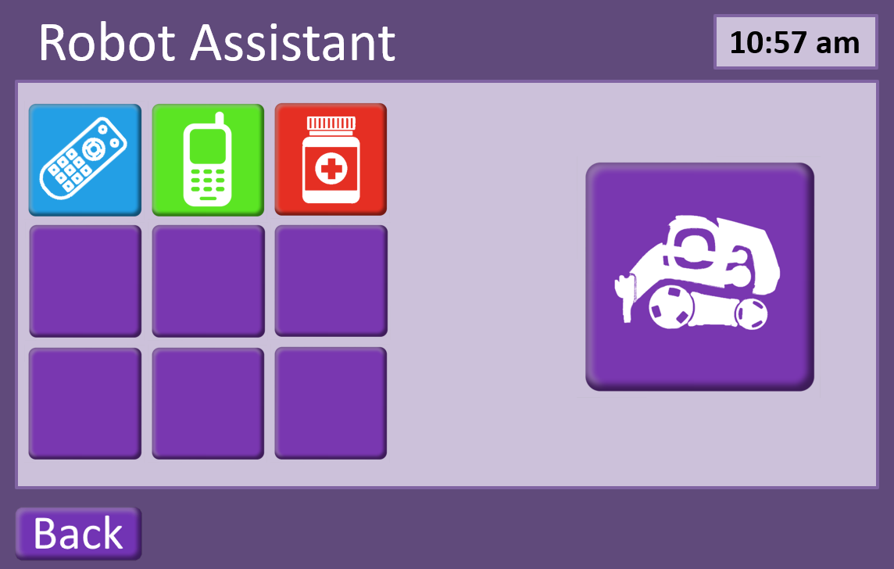

#### Ideal Path

1. User selects Cozmo tile on home screen of application.
   1. Cozmo boots up, application shows ‘waking’ screen, Cozmo says “I’m just getting ready.” Cozmo moves off charger
   2. Cozmo finds cubes and confirms which he can see
   3. Objects are displayed on application screen for selection
   4. Cozmo says “I’m looking for your stuff. When it lights up I’ve found it!” and spins on the spot, searching for the users objects.
2. Objects found are displayed on the GUI
3. Cozmo says, “ok pick one and then press confirm.”
4. User selects one object
   1. Object is shown on the rightmost tile. The tile becomes the same colour as the objects original tile. The word ‘confirm’ is shown on the tile below the object.
5. User presses confirm
   1. Cozmo moves to the selected object.
   2. Cozmo picks up object
   3. Cozmo brings the object back to the user
   4. Cozmo says “Is this the right one?”
   5. Pop-up window shows two buttons a green yes and a red no.
6. User presses the yes
   1. Cozmo says, “YAY!” and plays an excited animation

#### Deviations from Ideal Path

##### Overarching issues:

Cozmo is off its charger and is out of power. When Cozmo is selected from home screen, application displays a warning saying, “Cozmo needs put back on his cradle and charged before it can be used.” Once Cozmo is placed back on its cradle the application will display its current power levels. Cozmo cannot be sent on new tasks if it is under 10% charge.

1b) Cozmo cannot find any cubes on boot up. Application displays empty object panel and message saying “Cozmo can’t see anything it can fetch. Make sure any objects you want Cozmo to fetch for you are on the same surface as it.” Button is displayed under message saying, “Search for cubes again.”

3a) Cozmo cannot find route to selected object. If Cozmo becomes stuck or cannot reach object it will say, “I can’t seem to get to that one, can you see anything blocking my way?” The communication box on the application screen will then show a yes or no.

## Proposed Design for 1st February Presentation

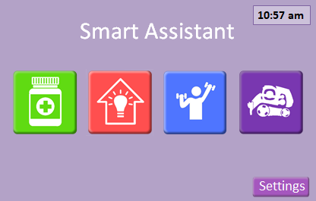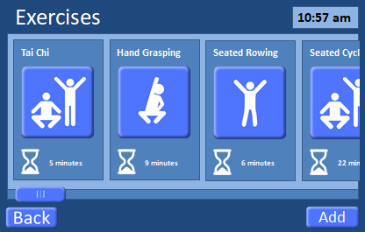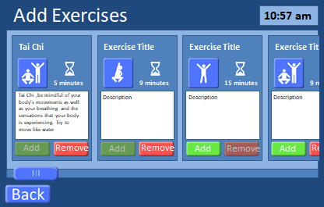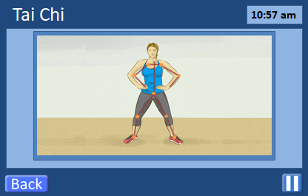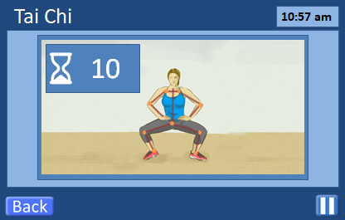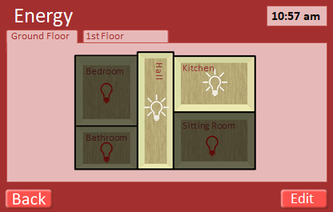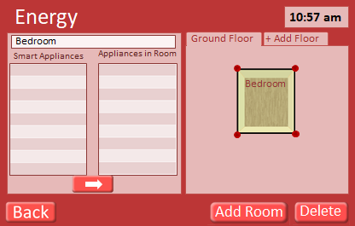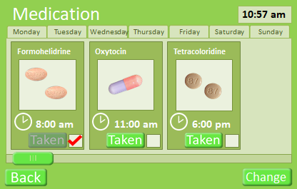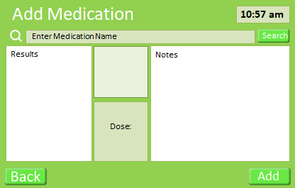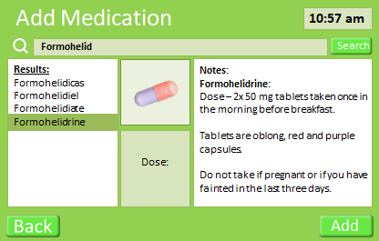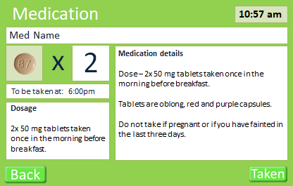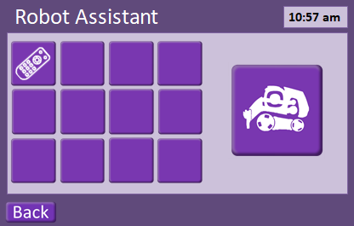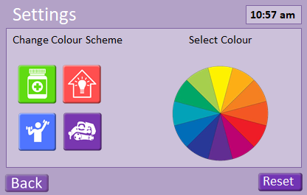

## Code for Cozmo Robot

Link to github repository containing code: https://github.com/Gordo851/DesignCourseworkSubmissionGroup4.git

# Screenshots

### Log-In Screen

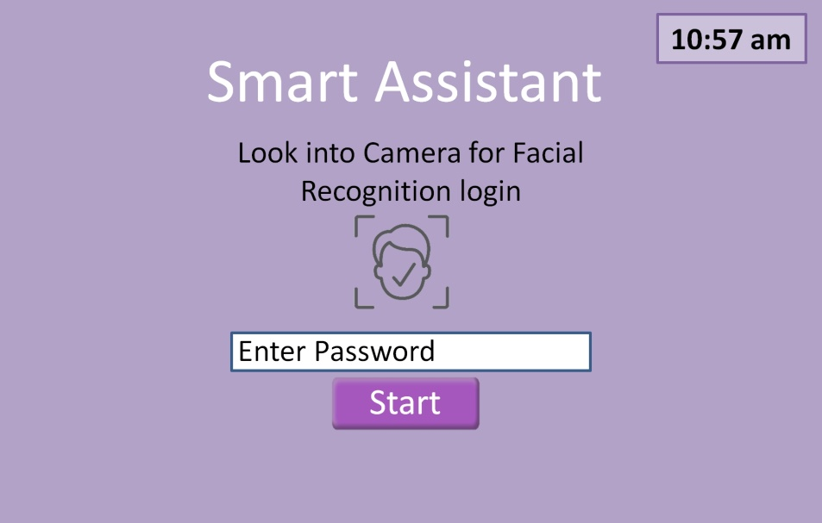

Figure 2 - The Log-in screen for the Interactive Display. The user only has to look into the camera which will have face recognition software; this will save the user from having to remember and enter a log-in password. Other stakeholders will be required to enter a password for access.

### Home Screen

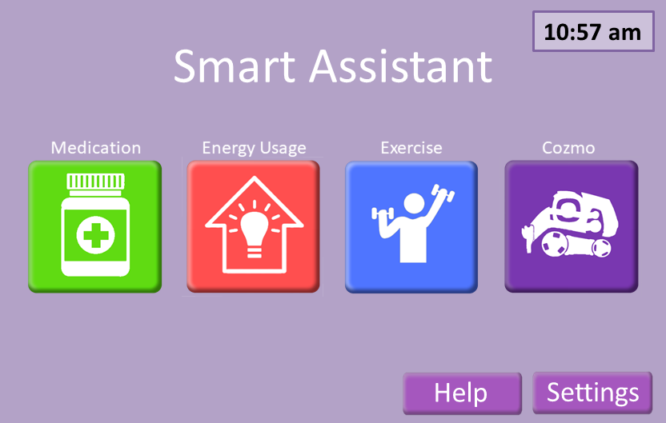

Help button brings up contact information

Colour coded buttons with “3D” effect to clearly indicate that they can be pressed.

Figure 3 - shows the homepage for the Interactive application. The four square buttons represent the four areas of interaction available to the user.

#### Help screen

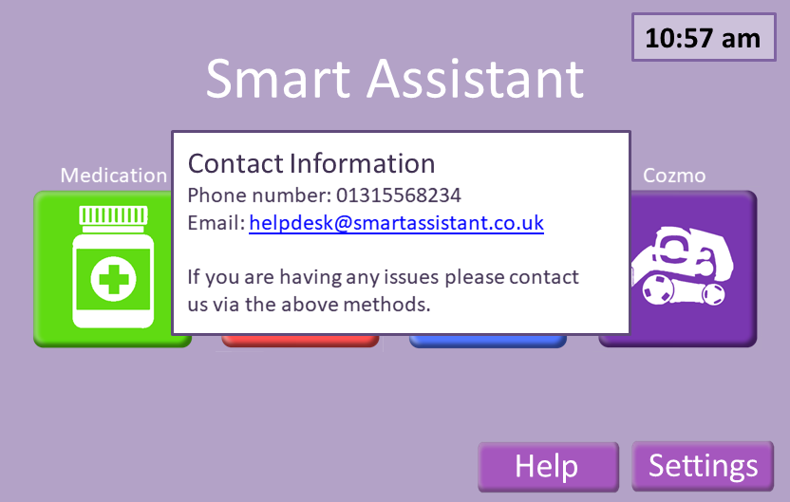

Figure 4 - shows the help message the appears when the "Help" button is pressed.

Can press the image of the medication to give more detail of the medication (see 7.1.6 Medication Details).

### Medication Screen

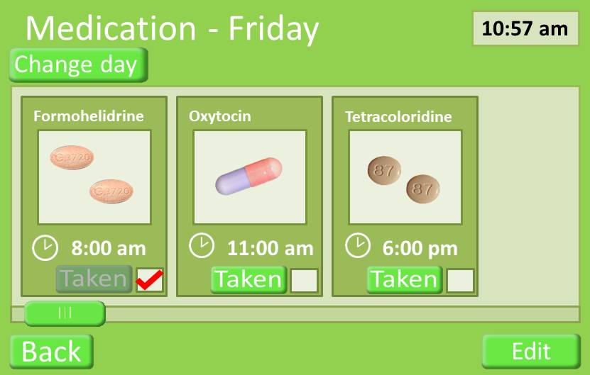

Press to change medication (see 7.1.5 Add Medication). This would be expected to be done with a doctor.

Press “taken” button when medication has been taken.

Figure 5 - The primary Medication Screen. This screen permits the user to 'tick' a medication taken. It provides a visual representation of the pill, along with the medication name and the time that the dosage should be taken.

#### Medication Screen with Warning about Dosage Time

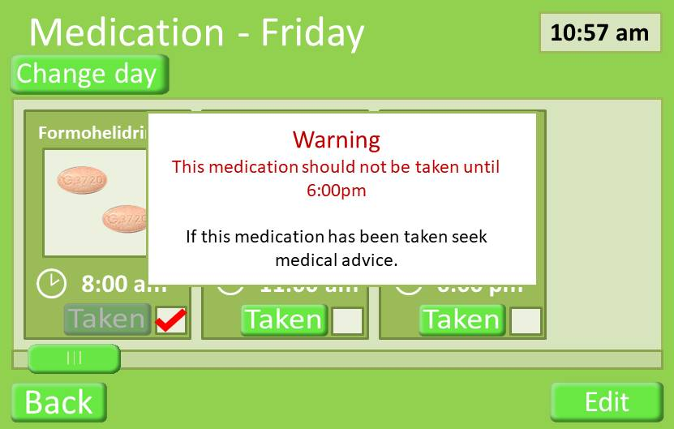

Figure 6 - This shows a warning overlay which occurs if the user attempts to tick that they are going to take a medication before the correct time has been reached when it should be taken.

### Medication screen change day

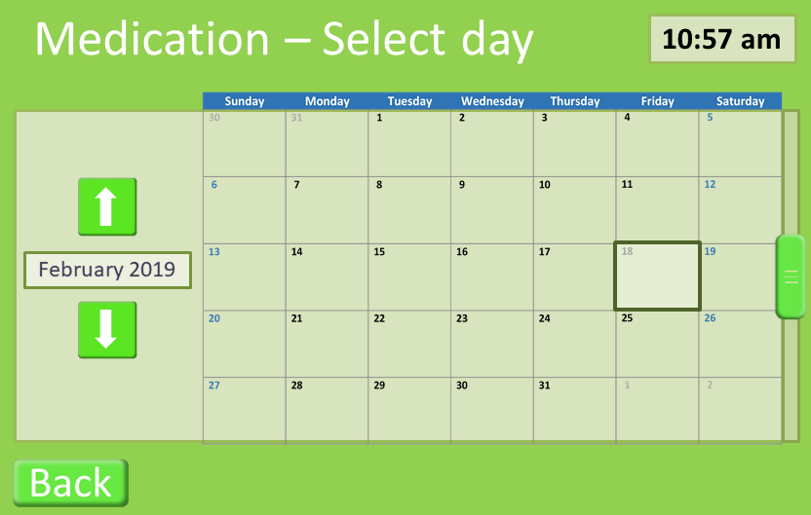

Figure 7 – the user can change the day that is being displayed by pressing the corresponding button.

### Add Medication Screen

Drugs can be searched for in the database.

The correct drug can be selected from the results.

Details of the selected drug

The Add button adds the drug to the user’s medication.

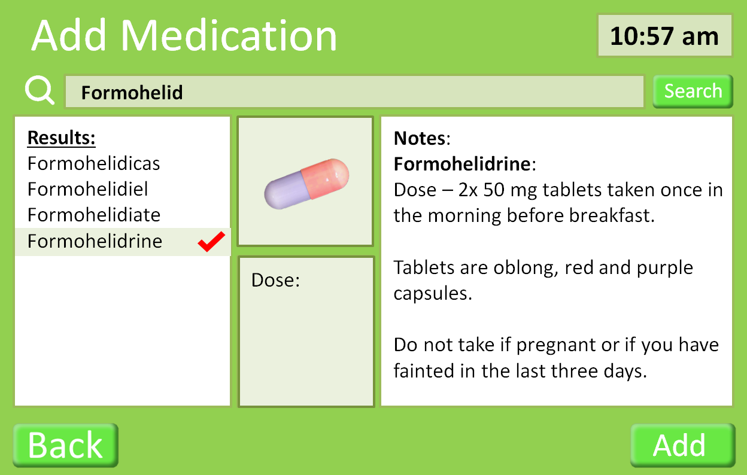

Figure 8 - The Add Medication screen provides a list of matching medication names against a search phrase. It provides information about the dosage and any contraindications.

### Medication Details Screen

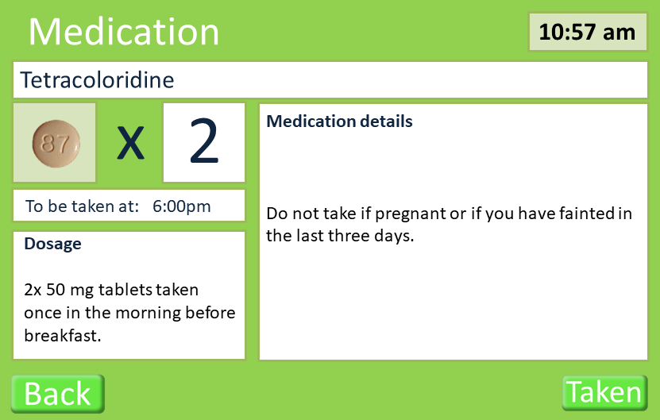

Figure 9 - The Medication Details screen gives an additional screen which can give the user information and a visual image of the associated tablet. It offers the user a mechanism to reassure the user that they are taking the right medication.

### Energy Screen

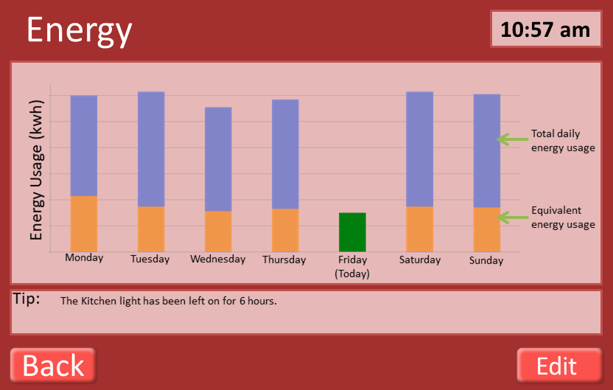

Total energy usage

Energy usage at 10:57am on given day

Edit button allows user to add smart devises to be tracked (see 7.1.11 Smart Appliances)

Figure 10 - The primary Energy Usage screen shows a week of bars which indicate total energy use that day with current use. Any helpful tips as to cutting back usage appear using information from the 'smart home' monitoring system.

### Energy Usage Breakdown Screen

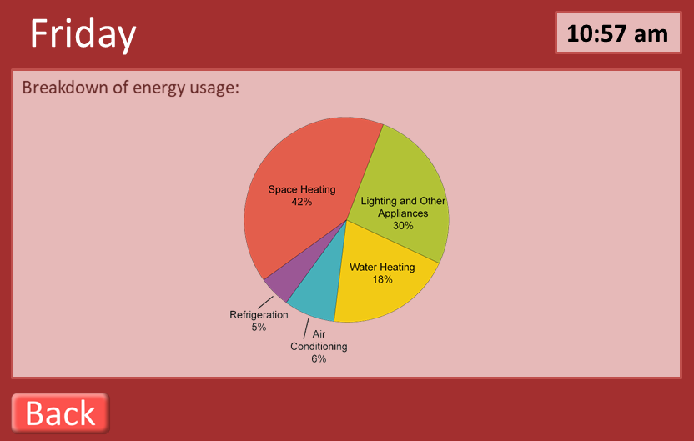

Figure 11 - This screen is displayed when the user taps a bar for a given day on the primary Energy page. It gives information about how energy is being used in the home up to that time.

### Smart Appliances Screen

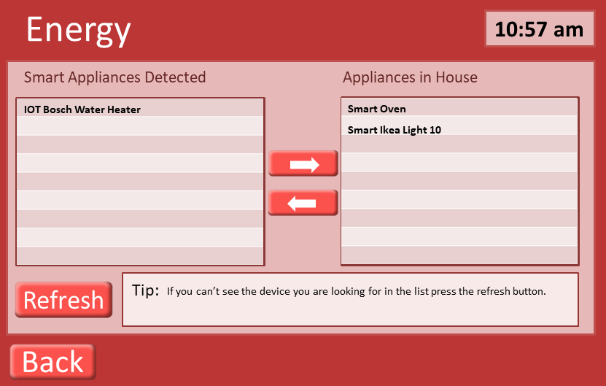

Use arrows to add remove devices from being tracked for energy usage.

Tip telling user how to get new devices linked to the application.

Figure 12 The Smart Appliance Screen shows the 'smart' appliances that the monitoring system has found to be in use and provides the addition of further devices to be monitored. These devices are monitored to give the user control over their energy usage.

### Exercise Screen

Press to start exercise

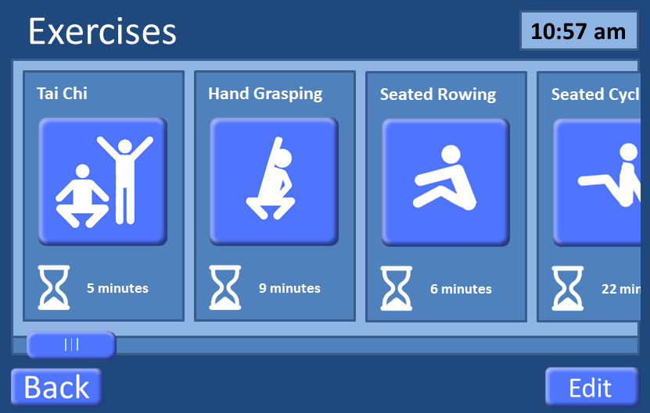

Press exercise button to view a run-through of the exercise to see if suitable (see 7.1.12 Exercise Run-Through).

Indicates expected time needed for exercise

Figure 13 – The main Exercise screen shows exercises which are available in the system for the user to participate in. It provides a time-to-complete guidance under each exercise. The ‘Back’ button takes the user to the previous screen (5.3 Home Screen).

### Add Exercises Screen

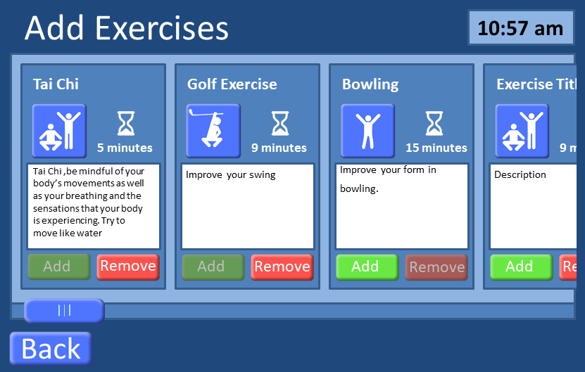

Press to add/ remove exercises to the personalised list

Figure 14 - This is the screen through which to add new exercises. A description is given along with a time-to-complete guide. Baylor Scott & White Health (2012) have highlighted that an appropriate medical assessment should be made so that a user knows the exercise is one that they can do.

### Exercise Run-Through

Countdown timer showing how long a position must be held.

Overlay of user showing how closely they are matching the correct positions

Exercise can be paused at any time

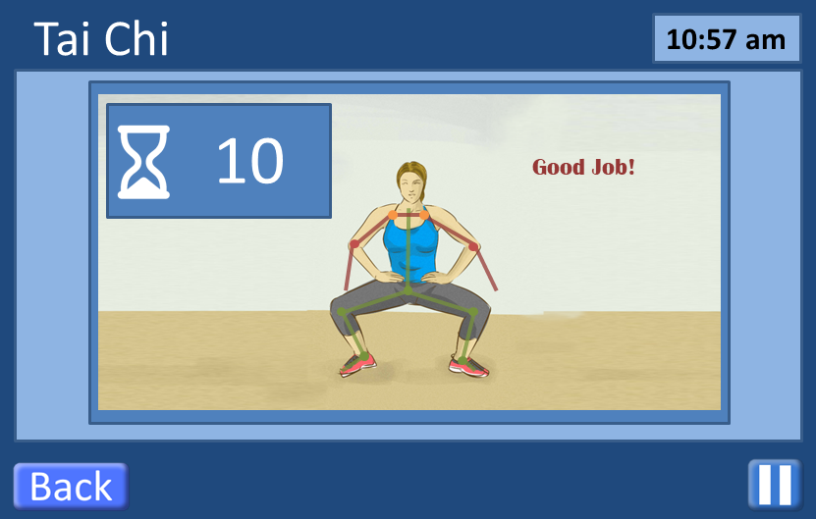

Figure 15 - This is an example of a specific Exercise screen. In the example, a movement in the Tai Chi exercise sequence is demonstrated by an image with an overlay of sensor points on the body to help the user identify where their arms and legs should be while performing this movement. The image and sensor points as an overlay were used as a mechanism to show rather than explain with words.

### Smart Robot (Cozmo)



Figure 16 - This is the Smart Robot screen. On this screen the user selects an item for the robot (Cozmo) to retrieve and it is through this screen that both Cozmo and the user interact to confirm the item to be retrieved and to confirm that the right item has been retrieved.

### Settings Screen

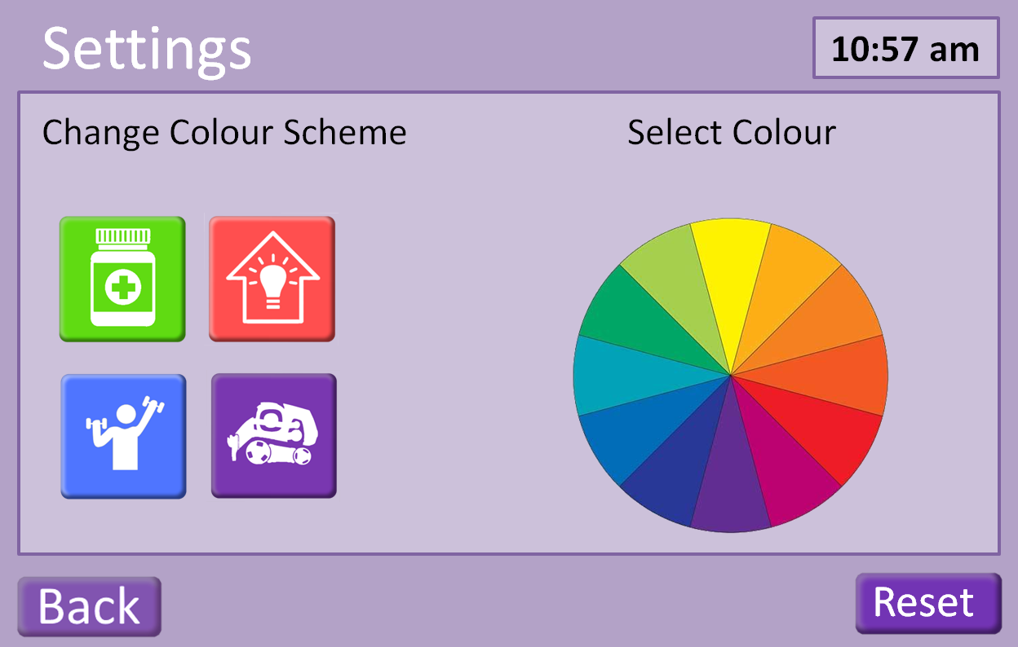

Figure 17 - This is the Settings screen through which the user may change the colour palette of the screens and buttons displayed in the Interactive Screen. By pressing the 'Reset' bottom at the lower right, the colours are returned to their defaults.

# Logbook

Log Book, Group Project Assignment, Part A

25th January 2019: Group Meeting

Discussed each member’s work with following aspects of assignment:

Persona – Mary’s most in-depth

These are some of Mary’s designs which were used as the discussion points for amendments, changes

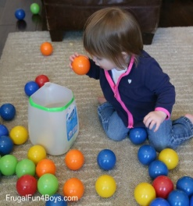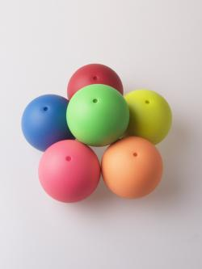

**Bag it!**

***Goal:***

Complete sequence to light exercise sash lights.

***How:***

Put on exercise sash with sensors and each arm band with sensors. These will detect movements to recognize when correct motion taken.

Drop virtual ball in screen mimicking image directions into virtual bag. May be done while seated or standing.

Virtual image shows which hand to use and whether the hand is lifted in front of body or to side to drop ball into virtual bag. Bag only appears when it is to be used.

***Success***:

Virtual exercise game keeps track and will note ‘success’ once sequences completed resulting in sash lights coming on and flashing.

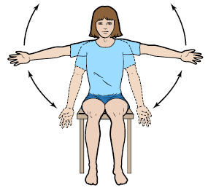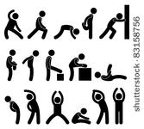

Use of Building – Gordon and Sam explained UK ‘smart home’ concept

Energy – Different views as to what this was

Chose majority view – ‘smart home’ utility ‘energy’ over exercise ‘energy’

Exercise graphic – view agreed that this needed to be more ‘block image’ with only one main image, less clutter

Mock-up of pills – Gordon’s previous work in psychology and with adults with autism helped define this – a pill image, not an outside container

Break-up of work – Sam to work on storyboard, Gordon and Mary to do research, persona, logbook, and critique Sam’s efforts

Designing for classic iPad – use Portrait

Graphical elements – make buttons obvious for pressing, not separate ‘enter’ button

Home Page – make these 3-d buttons

Energy – Floor plan – Map assign plus an Access Page

Change Pills display to provide lower level screen with more information

29th January 2019: Sam and Gordon met as Mary was at a meeting off-campus

Changes to Interface to incorporate lecture details

31st January 2019: Group Meeting

Sam did a walk-through of Interaction Design with Mary

Gordon and Mary offered additional suggestions, Sam still had some work he planned but had not yet implemented

Discussion was about robot – what did it look like, could Interaction Panel show robot had received request/was moving to comply/had returned with item and how user could confirm

Confusion that Sam and Gordon had not seen Vision announcement of presentation times – but Mary had from day before

Did the research show that design made use of personal experience as well as readings?

Decision which member would do what part in presentation

Confirmation that Tuesday Group Meeting would be reserved for Interaction Design project work through remainder of term – Mary to book for group

1st February 2019: Feedback notes from Presentation

Energy Displays: Need motivation for interaction. Currently not showing actual usage which can provide motivation.



Energy



Ground Floor



1st Floor

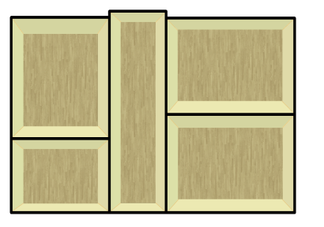

Bedroom

Kitchen

Sitting Room

Bathroom

Hall



**10:57 am**



Edit

Exercises: Need motivation to engage in exercise. Thought: add social element.

Other motivational options?

Medicine Display: No indication when missed dosage.

Personas: Build existing personas so that more than just one generic one.



Smart Assistant



Settings

**10:57 am**

5th February 2019: Group Meeting

Redesign of Energy Display to take into account Feedback:

Remove Floor Design – replace with bar charts to show day’s usage covering one week

Energy pop-up tips on main Energy page

Addition of Exercise Buddy to Exercise screens – Instructor, Image for you, and Image for Buddy – discussed but decided against

Add a button at the start of the ‘Add Exercises’ screen so user can suggest exercises

Exercises give feedback as to how well user is performing the exercise

Add Bowling, Add Golf – to give ‘pleasurable’ exercise to motivate.

Warnings on any of Main Menu Items makes button flash

Change to medicine selection – add tick mark

Report sections divided between group members, aim for 500 – 600 words each:

Sam will do GUI Design Layout

Gordon will do Medicine content

Mary will do Exercise content

Aim to have each report sections written for next Tuesday’s group meeting

Sam is uploading his version of a report template to GitHub for all to use with the aim of making report look similar

8th February 2019: Lab Visit to Assisted Living Facilities, Lyell Centre, introduction to Cozmo robot Bob

Class visited Assisted Living facilities, given first introduction to Cozmo robot and options for our interaction with and programming of

Group members were able to connect with robot, use the Sandbox application to give robot instructions, like ‘find block’, ‘lift block’, ‘move one step back’, and see that these were performed

This suggested how the interactions between robot and our designed interaction panel might require changes

Group members agreed that our aim is to use the Development Kit initially for our programming; then if we achieve programming for the planned interaction device, we may move on to Python coding to provide same

Group members took our assigned Cozmo robot Bob for two hours to familiarize our devices with connecting to it and to set up the Development Kit for programming Bob

Mary did not have a mobile device with her, so connecting with Cozmo will be during next lab access on Friday

Gordon noted that we could look for ways to add emotion in Bob as people enjoy interacting with a robot who shows some ‘human’ emotion

12th February 2019: Group Meeting, Sam is absent due to illness

Gordon has uploaded some example code for Cozmo programming; this will help Mary whose android tablet will probably be unable to link to Cozmo.

Gordon and Mary agreed that we should look at writing Python code for Cozmo responses. It was also agreed that we should investigate how/whether we could create the necessary GUI for Cozmo’s interaction.

For report, it needs rejigging – instead of initial and amended content sections, just explain what the content is, research to support that design decision.

Given 5 ½ hours on Thursday for robot programming, neither Gordon nor Mary can free themselves for the full time. So we will attempt to use 2 hours when we don’t have classes to test out Python programming that we hope to code before the Thursday session.

14th February 2019: Group and Individual Work.

Gordon has been testing some Cozmo coding in Python. Cozmo moves off the docking port, moves forward, and currently testing his code to have Cozmo pick up a block. Sam has asked that we look at the prototype for final changes. It was agreed that there would be a visual log-in for the owner. If this fails (ie, the person wanting to use the Interaction Device is not the owner), then a log-in screen should appear. This would allow other stakeholders to log-in and make changes or read setting. Add colours for boxes that Cozmo to retrieve. Further discussion on the Energy Use Screens. Add a legend, click on any given day, energy used on pie chart. Mary is going to take over the writing of the report sections for the time-being to give Gordon and Sam time to work on their tasks (programming Cozmo and completing the prototype). Additional meeting times have been agreed before presentation and report due dates.

15th February 2019: Lab in Living Assistance Facilities, Lyell Centre

Mainly Gordon testing code with Cozmo. Gordon continuing this through individual use of a booked study room. Mary and Sam watching, making some suggestions or asking questions.

The Lyell Centre Lab had so many Cozmos attempting to run that there were issues where a Cozmo would register blocks that were for a different Cozmo.

19th February 2019: Group Meeting

Gordon had to attend office meeting for his job, so Sam and I started the meeting. We agreed Python code for robot should go into the Appendix. We reviewed Prototype – an additional ‘warning’ message on medicines if user attempts to take medication before due time. We added a mechanism on log-in screen for user to look into camera for retina scan identification. On Exercises, a game of golf and a game of bowling have been inserted and can be added. Amendment on Medication taken screen – currently must press ‘Taken’ button but amendment will permit ticking in the box to achieve the same thing. Report amendments – for Storyboard, we agreed to put the version of the design that was given for the Storyboard presentation in the Appendix. Mary will note the changes to our design that came from feedback at the presentation and that came through the course lecture on security. We reviewed the requirements and screens with arrows pointing to buttons with further explanation fulfils the need to describe interactions available. Gordon arrived and gave an update on where he is with the Cozmo code. Sam gave Gordon the opportunity to work through the Prototype so that Gordon could give feedback. We agreed that our current meeting plan is good with all of our schedules.

20th February 2019: Group Meeting

As we do not have the Cozmo robot today, we will be organising our presentation for Friday.

Discussion as to how to present Prototype. Sam will show the Interactive Design apart from the Robotics section – he will pass over the presenting to Gordon. We ran through just the Interactive Design presentation, timing was just over 5 minutes. A few last minute changes to the Prototype. Read Theo’s eMail about timings to pick up robot, so those work for us.

21st February 2019: Group Meeting

We are reviewing Cozmo robot functionality for tomorrow’s presentation. Sam will be amending the Add Medications so that the interaction button reads ‘Edit’ to be able to delete a medication. He will amend the Energy screen to include ‘Tap bar to view usage details for that day’.

22nd February 2019: Group Meeting

Final run-through before presentation

Presentation Feedback

Home Screen: one-word label per button needed

Medicine: too busy – select ‘change button’

Take app to doctor

Medicine Details Screen – simplify details

Simplify warning message

Energy

What to do if a ‘smart’ appliance doesn’t show as available -> add Refresh button

Empty appliance list – ‘tip’ to turn it on and off – Research why they don’t connect - Sam

Research further how energy bills give previous information - Gordon

Exercise

Exercise icon images do not match the type of exercise

Cozmo

Consider start and end positions

Middle was fine

25th February 2019: Group Meeting

Final review of report. A few remaining actions which all will review and communicate agreement before submission.

# References

8 Creative Ways to Remember to Take Your Medicine Every Day. 3 August 2014. Retrieved 17 February 2019. Available from <https://www.drugs.com/article/taking-your-medicine.html>.

Allen, D., & Janda, K.B. (2006). The Effects of Household Characteristics and Energy Use Consciousness on the Effectiveness of Real-Time Energy Use Feedback : A Pilot Study [Online]. Retrieved 23 February 2019. Available from <https://www.semanticscholar.org/paper/The-Effects-of-Household-Characteristics-and-Energy-Allen-Janda/20c9ce3dd902edeb7e1110207a02d9bbe0bf561c>.

ArthurVideoSong. (2018 Oct 23). *Just Dance 2018, Rockabye*. Retrieved 21 February 2019 from <https://www.youtube.com/watch?v=tNUtAzh-C2U>.

Baylor Scott & White Health, (2012, 30 July), Hands-On Health Care Discussions. Scrubbing In: Tips for encouraging the elderly to exercise [online]. Retrieved 2 February 2019, from <https://scrubbing.in/encouraging-the-elderly-to-exercise/>.

BBC News, (2019). Retrieved 23 February 2019, from [BBC](https://www.bbc.co.uk/news) news application for android.

Bonino, D., Corno, F., De Russis, L. (2012) Home energy consumption feedback: A user survey. *Energy and Buildings 47* 383-393. <https://doi.org/10.1016/j.enbuild.2011.12.017>

Culén, A. L., & Bratteteig, T. (2013). Touch-screens and elderly users: A perfect match? *Changes.* ***7***(15) 460-465.

DailyCaring (2019). Seated Tai Chi for Seniors: 3 Simple Routines Improve Flexibility and Well-being [online]. Retrieved 29 January 2019, from <https://dailycaring.com/seated-tai-chi-for-seniors-3-simple-routines-improve-flexibility-and-well-being-video/>.

Darby, S. (2006). The Effectiveness of Feedback on Energy Consumption: A Review for DEFRA of the Literature on Metering, Billing and Direct Displays [online]. Environmental Change Institute, University of Oxford. Retrieved 23 February 2019. Available from <https://www.eci.ox.ac.uk/research/energy/downloads/smart-metering-report.pdf>.

Edwards, S. & Axe, S. (2015). The 10 ‘R's of safe multidisciplinary drug administration. *Nurse Prescribing 13*(8) 352-360. <https://doi.org/10.12968/npre.2015.13.8.398>.

Forlizzi, J., and Battarbee, K., (2004). DIS ’04 Proceedings of the 5th conference on Designing Interactive systems: processes, practices, methods, and techniques. Cambridge, Massachusetts, USA, 1 – 4 August 2004. Pp. 261-268. Available at: <https://doi.10/1145/1013115.1013152>.

Isakovic, M., Sedlar, U., Volk, M. & Bester, J. (2016) Usability Pitfalls of Diabetes mHealth Apps for the Elderly. *Journal of Diabetes Research 9.* <https://doi.org/10.1155/2016/1604609>.

Kontomanolis, E., Michalopoulos, S., Gkasdaris, G., and Gasoulakis, Z., (2017). The social stigma of HIV-AIDS: Society’s Role. *HIV//AIDS – Research and Palliative Care* ***9*** *(2017)*, 111 – 118. Doi: <https://dx.doi.org/10.2147%2FHIV.S129992>.

Lomas-Vega, R., Obrero-Gaitan, E., Molina-Ortega, F., & Del-Pino-Casado, R. (2017). Tai Chi for Risk of Falls. A Meta-analysis. *Journal of American Geriatrics Society.* ***65*** (9) 2037-2043. <https://doi.org/10.1111/jgs.15008>.

MedConfidential Org (2018). Retrieved from <https://medconfidential.org/about/>.

Montemerlo, M., Pineau, J., Roy, N., Thrun, S. & Verma, V. (2002) Experiences with a Mobile Robotic Guide for the Elderly. *American Association for Artificial Intelligence* 587-592.

Myers, W. (2015, 21 May). Eleven Fun Ways Older Adults can get in Shape [online]. Retrieved 2 February 2019, from <https://www.everydayhealth.com/senior-health/fun-ways-seniors-can-get-in-shape.aspx>.

NHS (2019, 4 July). Physical Activity Guidelines for Older Adults [online]. Retrieved 29 January 2019, from <https://www.nhs.uk/live-well/exercise/physical-activity-guidelines-older-adults/>.

Preece, J., Rogers, Y., and Sharp, H., (2015). *Interaction Design: Beyond Human-Computer Interaction* (Fourth Edition). Chichester, UK: John Wiley and Sons Ltd.

Pun, K., (2016). Do’s and Don’ts on Designing for Accessibility [online]. Gov.UK, Accessibility in Government. Available from: <https://accessibility.blog.gov.uk/2016/09/02/dos-and-donts-on-designing-for-accessibility/>.

Robinson, L., Smith, M., and Segal, J., (2019). Senior Exercise and Fitness Tips [online]. Retrieved 22 February 2019, from <https://www.helpguide.org/articles/healthy-living/exercise-and-fitness-as-you-age.htm/>.

Sandlund, E., & Norlander, T. (2000) The Effects of Tai Chi Chuan Relaxation and Exercise on Stress Responses and Well-Being: An Overview of Research. *International Journal of Stress Management. 7*(2) 139-149. <https://doi.org/10.1023/A:1009536319034>.

Vlasnik, JJ., Aliotta, SL. & DeLor B. (2005) Medication adherence: factors influencing compliance with prescribed medication plans. *Case Manager 16*(2) 47-51. <https://doi.org/10.1016/j.casemgr.2005.01.009>